Checklist on Student Progress - Political Science Major
(Effective January 1, 2015)

Name: Date:
Courses Taken:

Courses toward Political Science Major [10 courses required]

FOUNDATION COURSES (2):
- STA 101 Data Analysis and Statistical Inference or Higher

- POLSCI 175 Introduction to Political Philosophy or
POLSCI 275 Left, Right and Center
Field of Study:
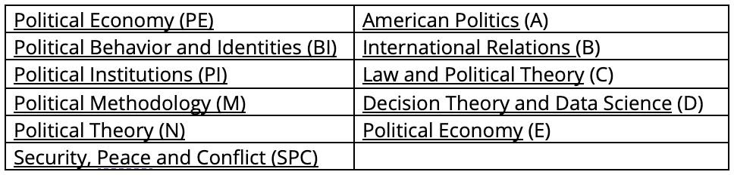

CONCENTRATION COURSES (3):
- Course in concentration 100 - Level

- Level Course in concentration 300 - Level

- Capstone course in concentration (POLSCI 401-699)

SUBFIELD DISTRIBUTION COURSES (2):
- Subfield course

- Subfield course

ELECTIVES (3):
- Elective
University Requirements Needed:
- Elective

- Elective

Note:
- Study abroad:
One semester: 2 credits allowed
One year: 3 credits allowed
- Capstone course must be taken at Duke
- Seven courses must be at the 200-level or higher
- Advanced placement credits do not count towards major

NOTES:

faculty advisor’s signature

student’s signature

